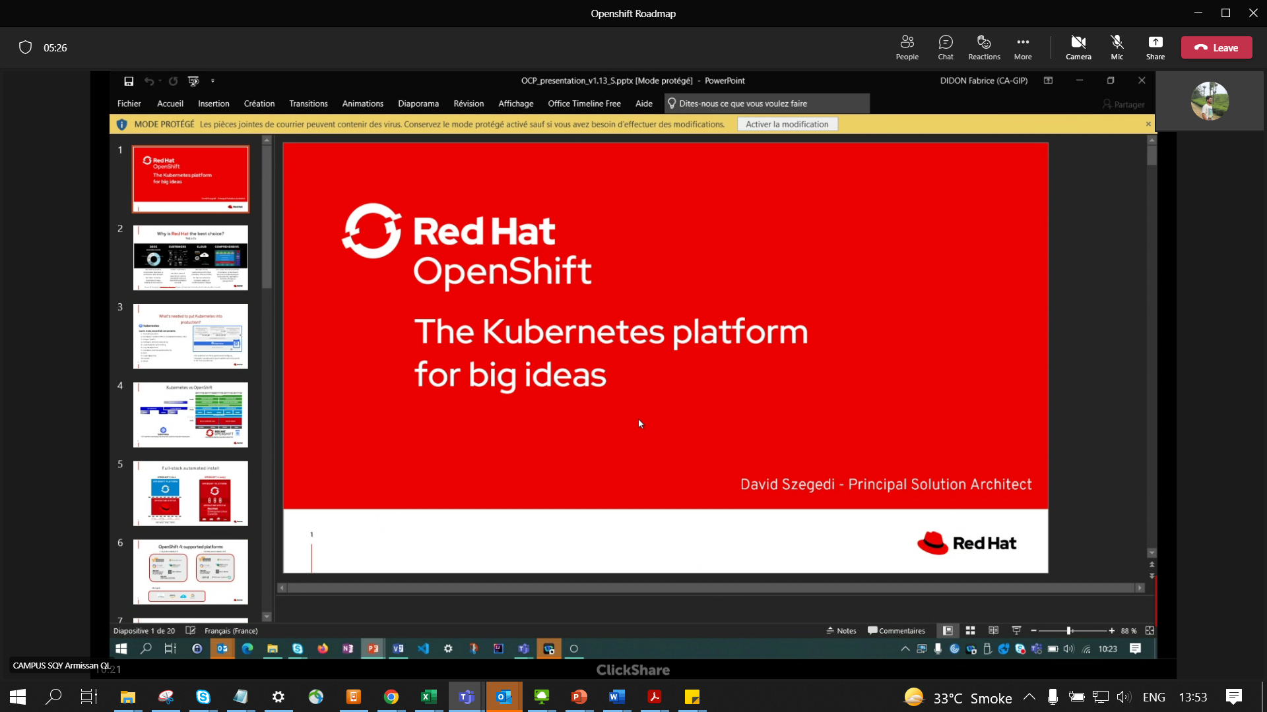

First Client to implement -Cacib-

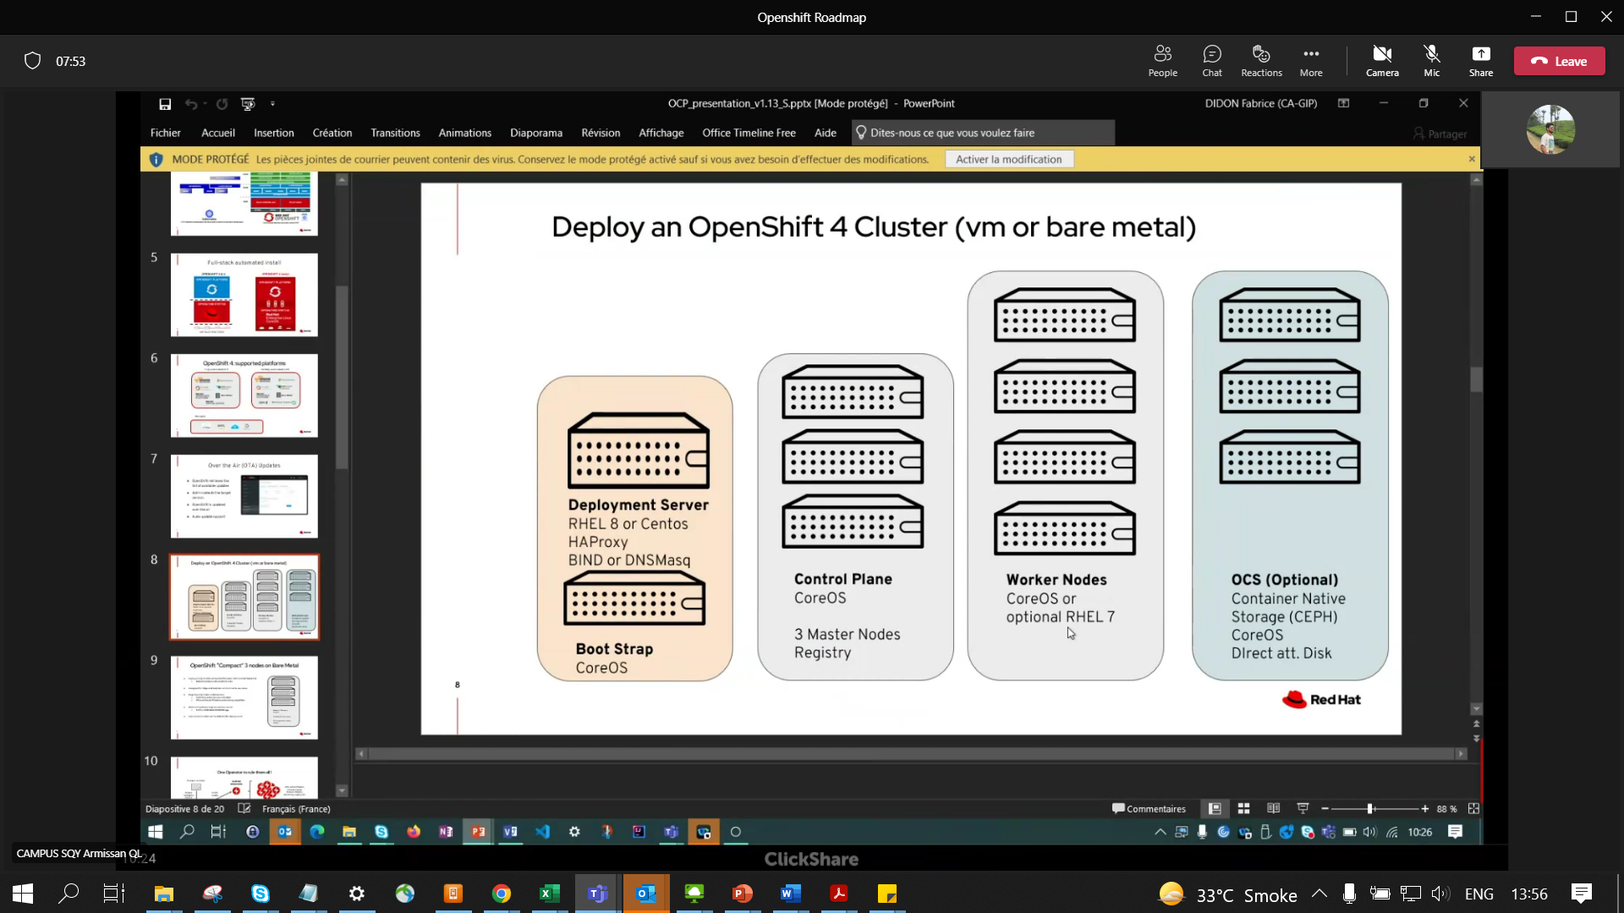

Storage – CEPG Cluster – persistent storage

ODF – new name of OCS

Control Plane = VM’s

Worker nodes , ODF Nodes = Bare Metal or Physaical Servers

HAPRoxy = VM again

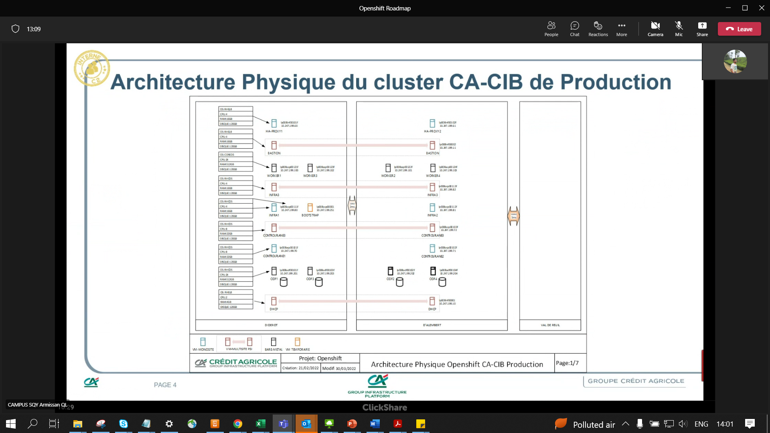

CoreOS – becoz we use DHCP

OC commands for CLI

Never connec to CoreOS machines with SSH

Only CLI (OC commands) & Web GUI

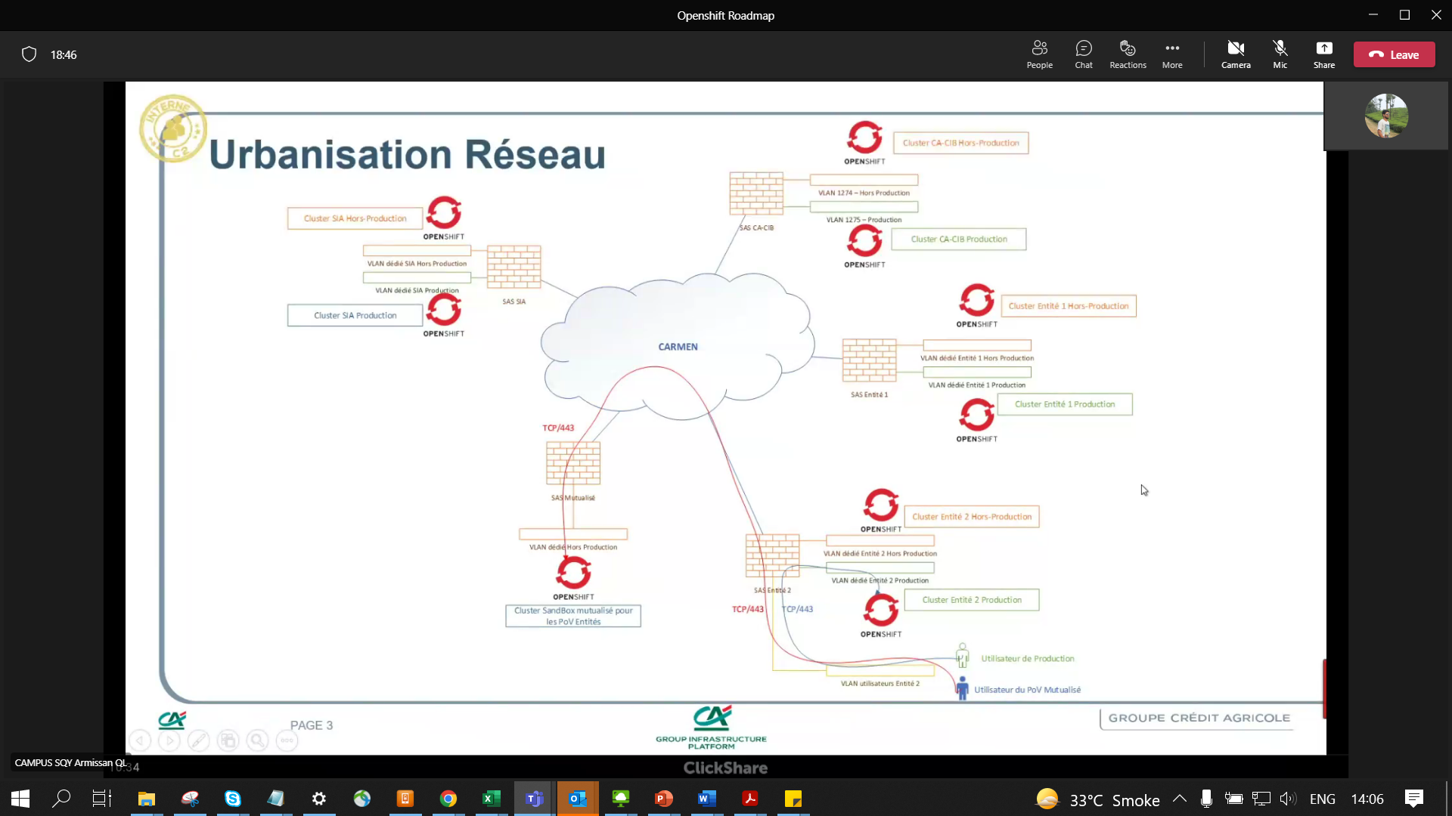

2 Clusters

VLAN 1274 – Non Prod

1275 – Prod

Dedicated VLAN for each Cluster

1 Cluster have -> 3 Infra Nodes , 3 Control Plane Nodes (Master node), 4 BareMetal Computes/workers, 4 BareMetal ODF Storage

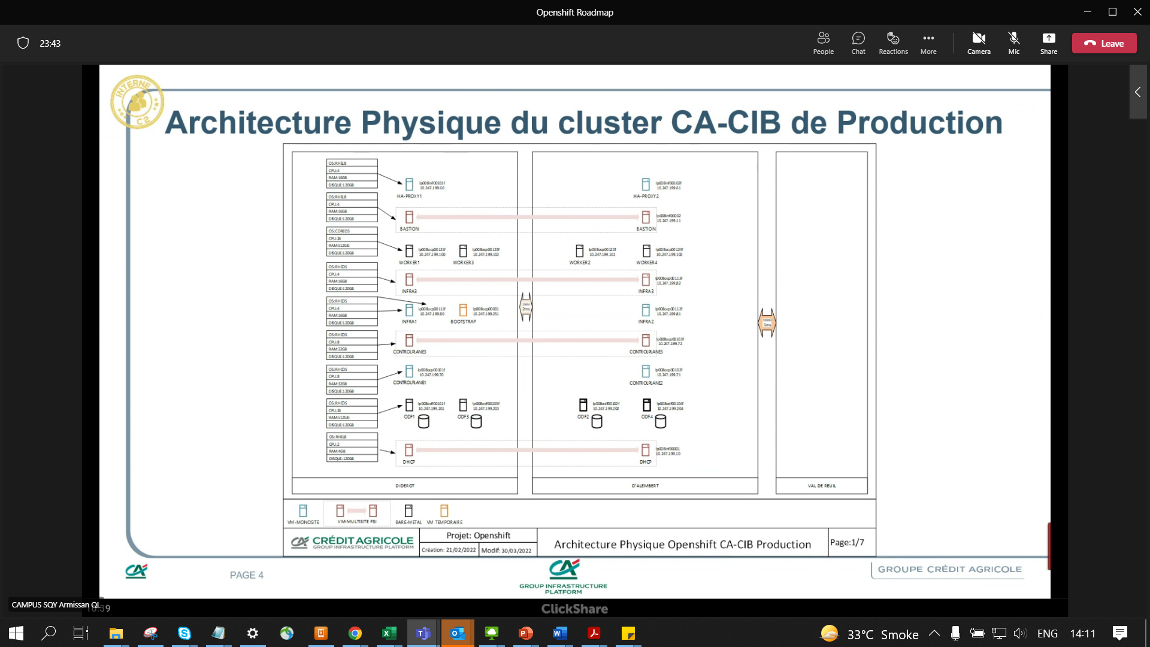

NEW DATECENTER – Normandy 2

2ms b/w DID <-> DAL

5 ms b/w DID <-> Normandy DAL <-> Normandy

Redhat Openshift 4.8 for Cacib

Artifactory – manages Registry (having images with Application, packages etc.) = team is Socle Natif

Once Openshift is deployed by Unix team, we don’t have any more responsibility for managing it.

Its all with the Client. Application, packages etc under their responsibility.

etcd – backup /data protection by – Kasten (Veeam team) = S3 storage for backup dump

Cacib – prod – by End of June 2022